**UNIT-I**

1. Define operations research and discuss the scope of operations research.

**1. Define Operations Research and discuss the scope of Operations Research.**

**Operations Research (OR)** is a discipline that uses scientific methods and mathematical models to solve complex decision-making problems, often involving the optimal use of limited resources. It provides tools and techniques to improve decision-making in various fields like management, industry, and defense.

**Scope of Operations Research** includes:

* **Agriculture**: Optimal allocation of land and water resources.
* **Defense**: Developing strategies to maximize gains in military operations.
* **Finance**: Optimizing capital investments, cash flow, and risk management.
* **Marketing**: Product selection, advertising strategy, and sales optimization.
* **Personnel management**: Efficient personnel selection and job assignments.
* **Insurance (LIC)**: Deciding premium rates for policies.
* **Research and Development**: Project selection and allocation of resources

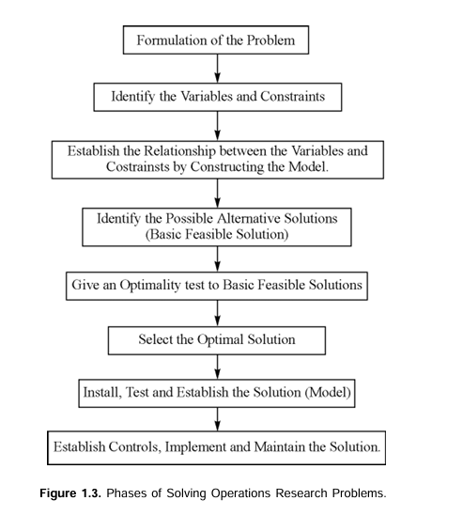

___________________________________________________________________________

1. By graphical method, solve the following LPP.

Max Z = 100X+40Y

Subjected to: 5X+2Y ≤ 1000

3X+2Y ≤ 900

X+2Y ≤ 500

And X,Y ≥ 0.

[**https://youtu.be/8IRrgDoV8Eo?si=30r8b2URBaI8dec7**](https://youtu.be/8IRrgDoV8Eo?si=30r8b2URBaI8dec7)

___________________________________________________________________________

1. Use Two-phase simplex method to solve

Maximize Z= 5X1-4x2+3x3

Subjected to constraints: 2X1+x2-6x3 =20

6X1+5x2+10x3 ≤ 76

8X1-3X2+6X3 ≤ 50

and X1, X2, X3 ≥ 0

[**https://youtu.be/zJhncZ5XUSU?si=e5EaLBbFZ4dqsJa6**](https://youtu.be/zJhncZ5XUSU?si=e5EaLBbFZ4dqsJa6)

___________________________________________________________________________

1. By graphical method, solve the following LPP.

Maximize Z = 30X1 + 40X2

Subject to 3X1 + 2X2 ≤ 600

3X1 + 5X2 ≤ 800

5X1 + 6X2 ≤ 1100

and X1 ≥ 0, X2 ≥ 0

[**https://www.youtube.com/watch?v=O6QO3J_85as&list=PLabr9RWfBcnoJJebSlOYj004xKOxJr9o6&index=4**](https://www.youtube.com/watch?v=O6QO3J_85as&list=PLabr9RWfBcnoJJebSlOYj004xKOxJr9o6&index=4)

___________________________________________________________________________

1. What are the advantages and applications of OR.

**5. Advantages and Applications of OR**

**Advantages**:

* Helps decision-makers take better and quicker decisions.
* Improves the quality of decisions by providing alternatives.
* Offers models to understand and control problems.
* Reduces failure risks by suggesting the best possible solution.
* Optimizes resource utilization, such as minimizing costs and maximizing profits.
* Identifies the limitations and scope of a problem.

**Applications**:

* Agriculture, Finance, Marketing, Personnel management, and Defense as discussed in the scope of OR.
* Public sectors for economic and social planning

___________________________________________________________________________

1. Define the LPP. Explain LPP by using an example.

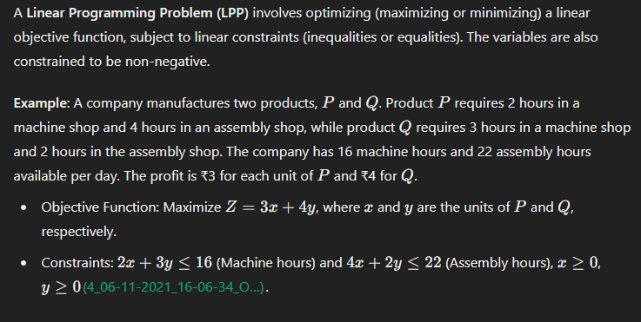

___________________________________________________________________________

**UNIT-II**

1. Solve the following transportation problem by using Vogel’s approximation method.

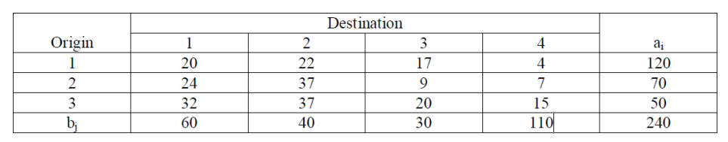

[**https://youtu.be/z3zjieArlAE?si=RR6tJRLj9jSh-vfF**](https://youtu.be/z3zjieArlAE?si=RR6tJRLj9jSh-vfF)

1. A workshop contains four persons available for work on the four jobs. Only one person can work on any one job. The following table shows the cost of assigning each person to each job. The objective is to assign person to jobs such that the total assignment cost is a minimum.

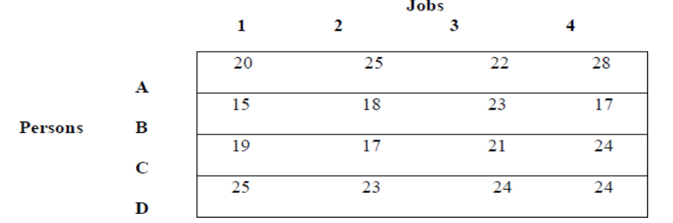

<https://www.youtube.com/watch?v=rrfFTdO2Z7I&list=PLabr9RWfBcnrP8NM55-ta-sT-G6fg8A8Z>

1. Consider the following traveling salesman problem. Design a tour to five cities to the salesman such that minimize the total distance. Distance between cities is shown in the following matrix.

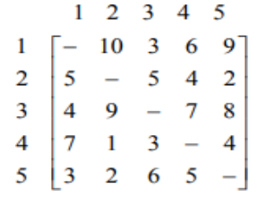

[**https://youtu.be/k3I2eThAErc?si=-C0Ykeg1u7x5XPVu**](https://youtu.be/k3I2eThAErc?si=-C0Ykeg1u7x5XPVu)

1. Find the initial basic feasible solution for the following table using Least cost cell method.

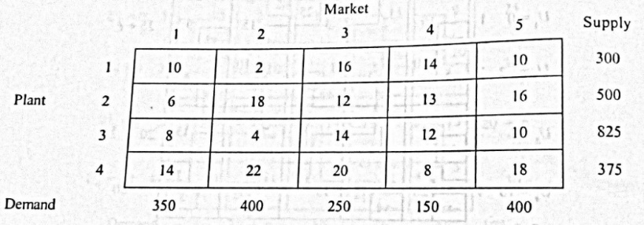

[**https://youtu.be/9tb6oRATVTw?si=3equs3i_gQKFO6Q7**](https://youtu.be/9tb6oRATVTw?si=3equs3i_gQKFO6Q7)

1. A department of a company has five employees with five jobs to be performed. The time (in hours) that each man takes to perform each job is given in the effective matrix.

|  |  |  |  |  |  |
| --- | --- | --- | --- | --- | --- |
|  | I | II | III | IV | V |
| A | 10 | 5 | 13 | 15 | 16 |
| B | 3 | 9 | 18 | 13 | 6 |
| C | 10 | 7 | 2 | 2 | 2 |
| D | 7 | 11 | 9 | 7 | 12 |
| E | 7 | 9 | 10 | 4 | 12 |

<https://www.youtube.com/watch?v=rrfFTdO2Z7I&list=PLabr9RWfBcnrP8NM55-ta-sT-G6fg8A8Z>

1. Luminous lamps has three factories F1, F2 and F3 with production capacity 30,50 and 20 units per week respectively. These units are to be shipped to four ware houses W1, W2, W3 and W4 with requirements of 20,40,30 and 10 units per week respectively. The transportation costs (in Rs) per unit between factories and warehouses are given below:

|  |  |  |  |  |  |
| --- | --- | --- | --- | --- | --- |
|  | W1 | W2 | W3 | W4 | Supply |
| F1 | 4 | 5 | 4 | 7 | 30 |
| F2 | 6 | 6 | 5 | 4 | 50 |
| F3 | 7 | 5 | 8 | 12 | 20 |
| Demand | 20 | 40 | 30 | 10 |  |

Find an initial basic feasible solution to the above transportation problem by using the North-West corner rule.

<https://youtu.be/ItOuvM2KmD4?si=yHkBZ3wdCmzI74nV>

**UNIT-III**

1. Define sequencing? Explain the principal assumptions made while dealing with sequencing problems?

**1. Define Sequencing and the Principal Assumptions in Sequencing Problems.**

**Sequencing** refers to the process of determining the order in which a series of tasks should be performed on different machines or by different workers to optimize certain criteria like minimizing total time or costs.

**Principal Assumptions** in sequencing problems:

* The processing times of tasks are known and fixed.
* No machine can handle more than one task at a time.
* The order of jobs on machines cannot change once determined.
* Setup and removal times are either negligible or included in processing times.
* Jobs are processed according to a given sequence without interruption​

___________________________________________________________________________

1. Give Johnson’s procedure for determining an optimal sequence for processing ‘n’ items on two machines.

**2. Give Johnson’s Procedure for Determining an Optimal Sequence for Processing ‘n’ Items on Two Machines.**

**Johnson’s Procedure** is used for minimizing the total time required to complete ‘n’ jobs on two machines. The steps are as follows:

1. List the jobs and their respective processing times on two machines.
2. Select the job with the smallest processing time. If it is on the first machine, place the job first in the sequence; if it is on the second machine, place the job last.
3. Repeat the process for the remaining jobs, always placing the job with the smallest time either at the beginning or end of the sequence.
4. This process continues until all jobs are sequenced​

___________________________________________________________________________

1. Shahi export house must process five items through three stages of production, I.e., cutting, sewing and pressing. Processing times are given in the following table.

|  |  |  |  |
| --- | --- | --- | --- |
| Item | Cutting (Ai) | Sewing (Bi) | Pressing (Ci) |
| 1 | 3 | 3 | 5 |
| 2 | 8 | 4 | 8 |
| 3 | 7 | 2 | 10 |
| 4 | 5 | 1 | 7 |
| 5 | 2 | 5 | 6 |

[**https://www.youtube.com/watch?v=c6CpNqdJWDw&pp=ygUUbiBqb2JzIDMgbWFjaGluZXMgb3I%3D**](https://www.youtube.com/watch?v=c6CpNqdJWDw&pp=ygUUbiBqb2JzIDMgbWFjaGluZXMgb3I%3D)

1. There are nine jobs, each of which must go through two machines P and Q in the order PQ, the processing times (in hours) are given below:

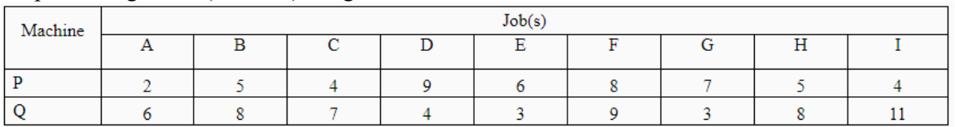

<https://youtu.be/jonespBF9yk?si=b1SCNVUE5aRltnqW>

Find the sequence that minimizes the total elapsed time T. Also calculate the total idle time for the machines in this period.

**Last modified on 19-09-2024 - 00:31   
 @Mr_immortal**